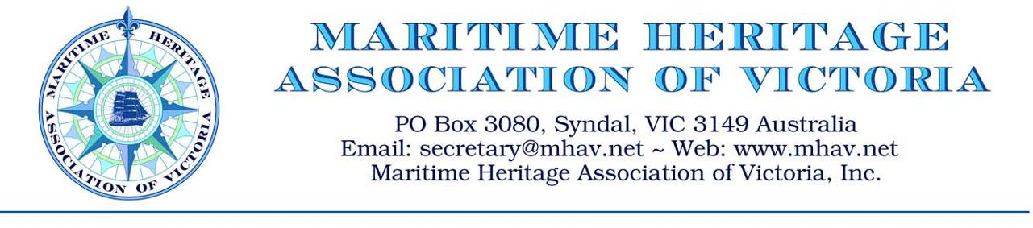
ANNUAL GENERAL MEETING TUESDAY 22 NOVEMBER 2011
President’s Report
Firstly a warm welcome to all members and guests, in particular our new members. Thank you also to our committee members for their efforts during the year with special appreciation to Lindsay Rex, our retiring long serving committee member,
My apologies for not being present for this AGM as I have been called away to crew on WA’s sail training ship.
This report brings to a close my two year tenure as President.
This organisation was formed with one principle purpose – namely the promotion of the development of a maritime heritage centre and working seaport at the Williamstown Port of Melbourne Authority site. Much has been written and even more spoken about this project. The MHAV has been promoting this development for many years and over the last 14 months has provided financial and hands on support to Seaworks. However in spite of our many advances to Parks Victoria and the Seaworks board, we have been frustrated by a consistent lack of response to discuss plans for the future. We have met with state museum officers and sent many letters to state politicians being met with similar disregard accepting that a single voice does not attract much attention.
Some people may have given up but others still believe that the Williamstown site is the ideal and appropriate site for the development of the major maritime heritage centre for Melbourne. The Seaworks lease with Parks is due for review on 27th August next year.
In the meantime, as an important contribution to supporting and promoting maritime heritage across the state, we are working with the Maritime Museum of Victoria which represents Melbourne and state regional maritime museums. Over the last 18 months, 14 newsletters and bulletins have kept supporters informed on maritime heritage activities around the state. We continue to try to find suitable homes for maritime artifacts being offered to us.
As we know the Williamstown site provides a unique location with a strong maritime heritage, yet Melbourne remains the only capital city without a major maritime museum. Like it or not, the result speaks for itself, we have not worked hard enough to achieve the objective. We still need to lobby to the three levels of government, Parks Victoria and potential commercial sponsors.
Who is responsible for overseeing the preservation of Victoria’s and the nation’s maritime heritage? Maritime museums in other states are sponsored by their state government. Regional councils support their local maritime museums. More effort is required to understand what is required to attract the required attention of the relevant bodies.
The work of the MHAV is presently conducted by only a few people. Considerably more support is required to continue working on the MHAV’s objective,
I look forward to meeting again in the near future.

Tim Horton
President

