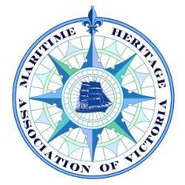
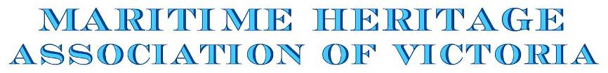

Annual General Meeting - 27th October 2010
President’s Report
The last twelve months have been particularly eventful, culminating in the Seaworks Foundation being granted the lease to manage the Williamstown site.
Our paid membership has increased, at least partly due to keeping members and the broader maritime heritage community informed on current events and developments.
The efforts of our committee members and members who supported our activities over the last twelve months need to be recognised with events and activities including:
- Members’ function last November
- Melbourne’s inaugural Wooden Boat Festival where the MHAV sponsored two ferries and affiliated maritime organisations
- Alan Edenborough’s presentation in July
- The sponsorship of this month’s Mission to Seafarers Maritime Art Exhibition
- Promotion of the activities of associated maritime heritage organisations
- Production and distribution of newsletters
- Promoting the Seaworks development
The MHAV was formed with one principle purpose, namely to promote and support the development of the Williamstown site, in the belief that the maritime heritage community will be best served by having a state centre, where we are all able to work together. For more than eight years your association has been working to this end.
- In July 2008, the MHAV contributed to the Strategic Development Plan by presenting a detailed submission to the consultants, Connell Wagner
- An awareness campaign was recently conducted with state politicians yielding letters of encouragement from the Premier, Minister for Planning and the Deputy Leader of the Opposition
The Seaworks lease was officially announced on 27th August this year, along with the Victoria University lease and the release of the Strategic Development Plan (SDP). The SDP provides a broad coverage and narrative of site planning and land use issues. References are made to the proposed use of the heritage listed buildings and two slipways. Endorsing the original Strategic Statement issued by the Seaworks Foundation, the SDP provides a “Proposed Development Schedule” which is very broad and now out of date.
The enormous challenge for Seaworks and its supporters is to develop a Business Plan which deals with both the immediate and medium term issues, priorities and schedules. The daunting scale of the planning process becomes apparent when considering the multitude of topics and issues.
Guiding Principles in the Seaworks Strategic Statement include:
“Planning for the site will welcome partnerships with others to encourage and nurture maritime heritage ventures and other maritime interests that complement the site”
“The planning process will be open and transparent, with opportunities for public participation and review”
Therefore, alongside assisting with the immediate priorities, we look forward to working with Seaworks and the other key stakeholders, to proceed with the planning process, continue promoting the Williamstown development and provide active support.
“Working together to transform the dream into reality”

Tim Horton
President

